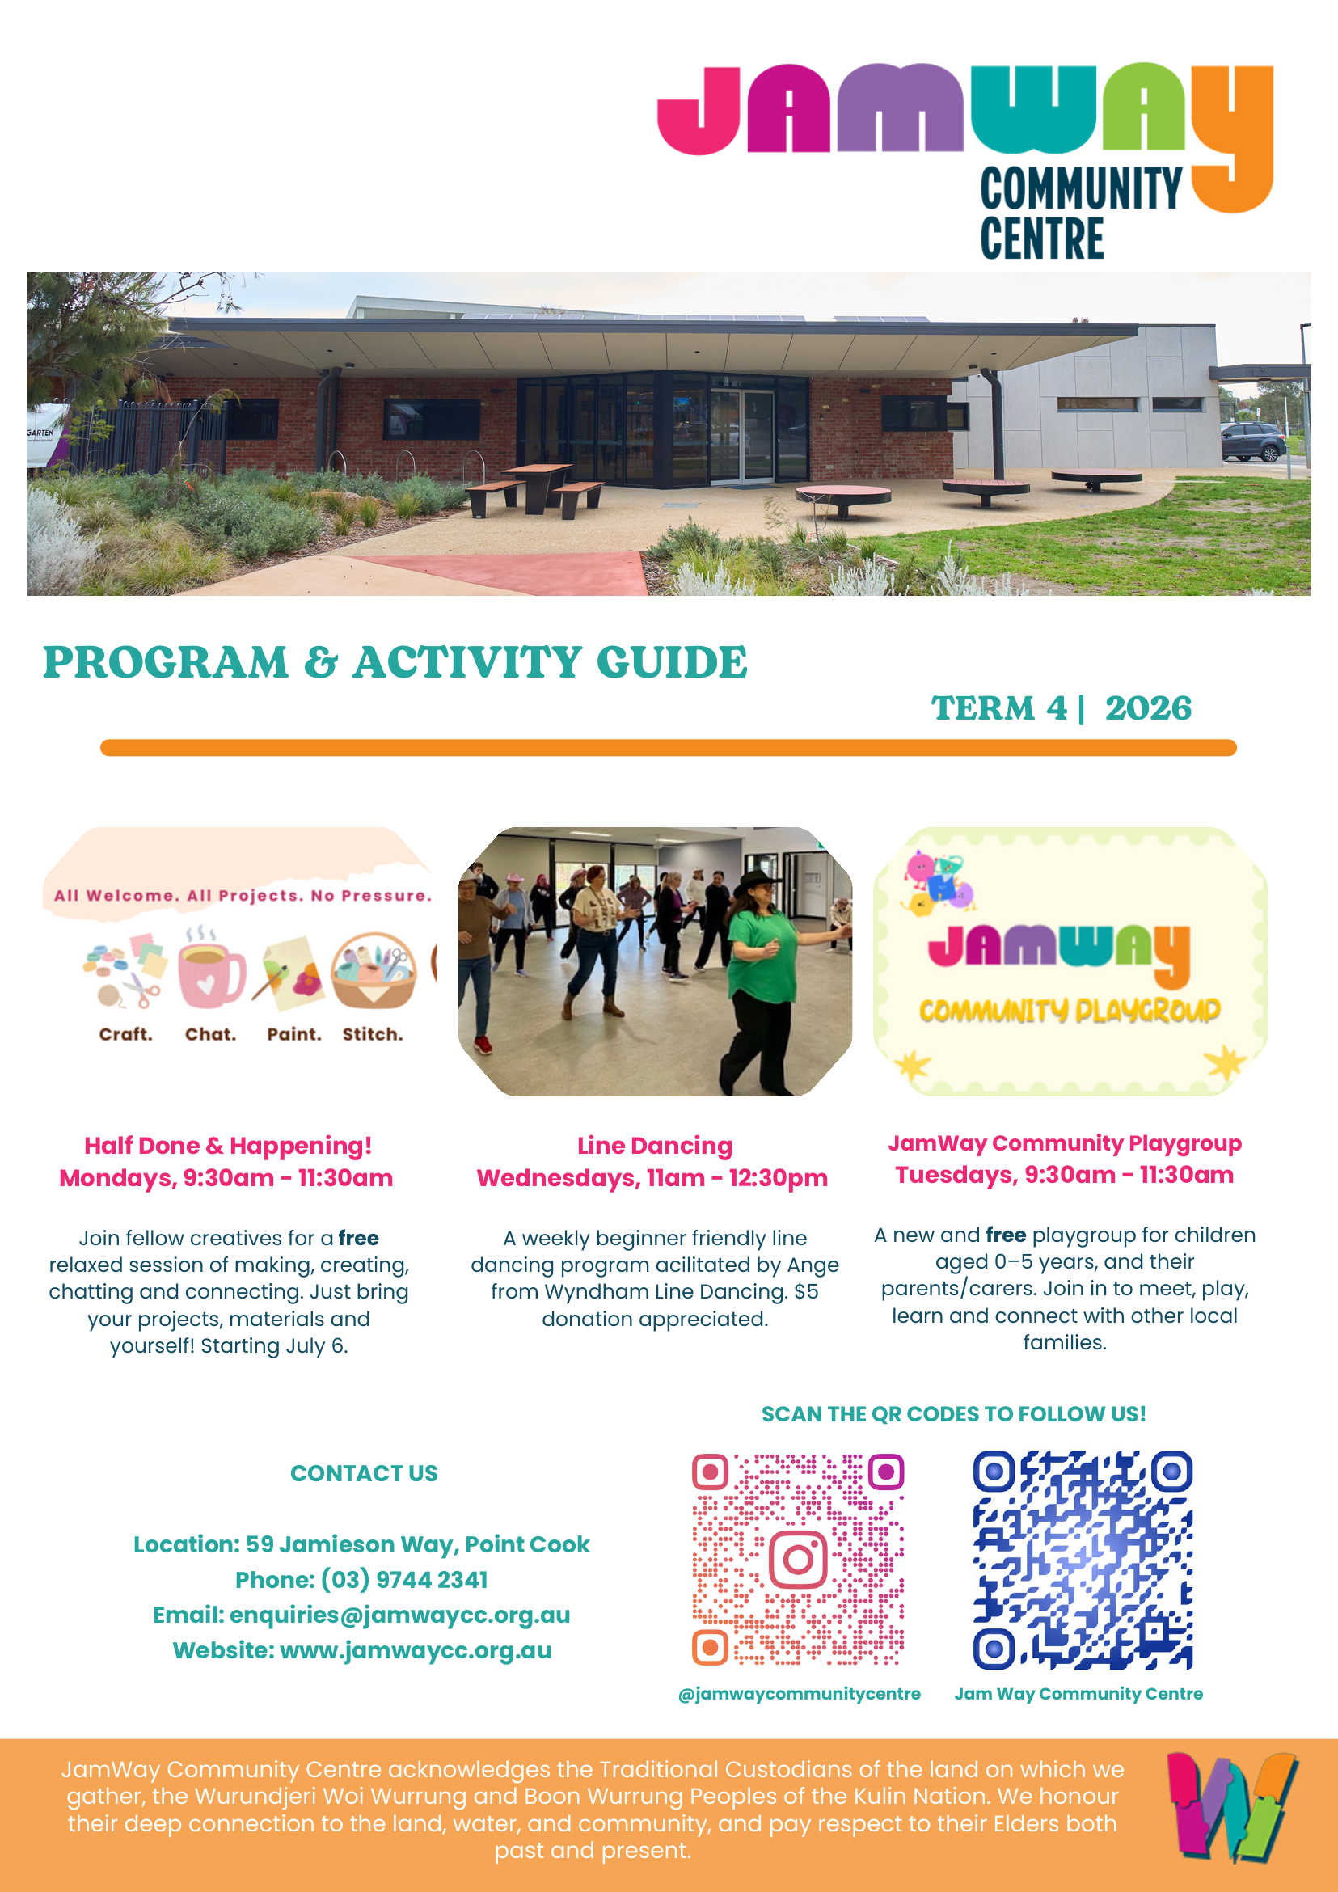
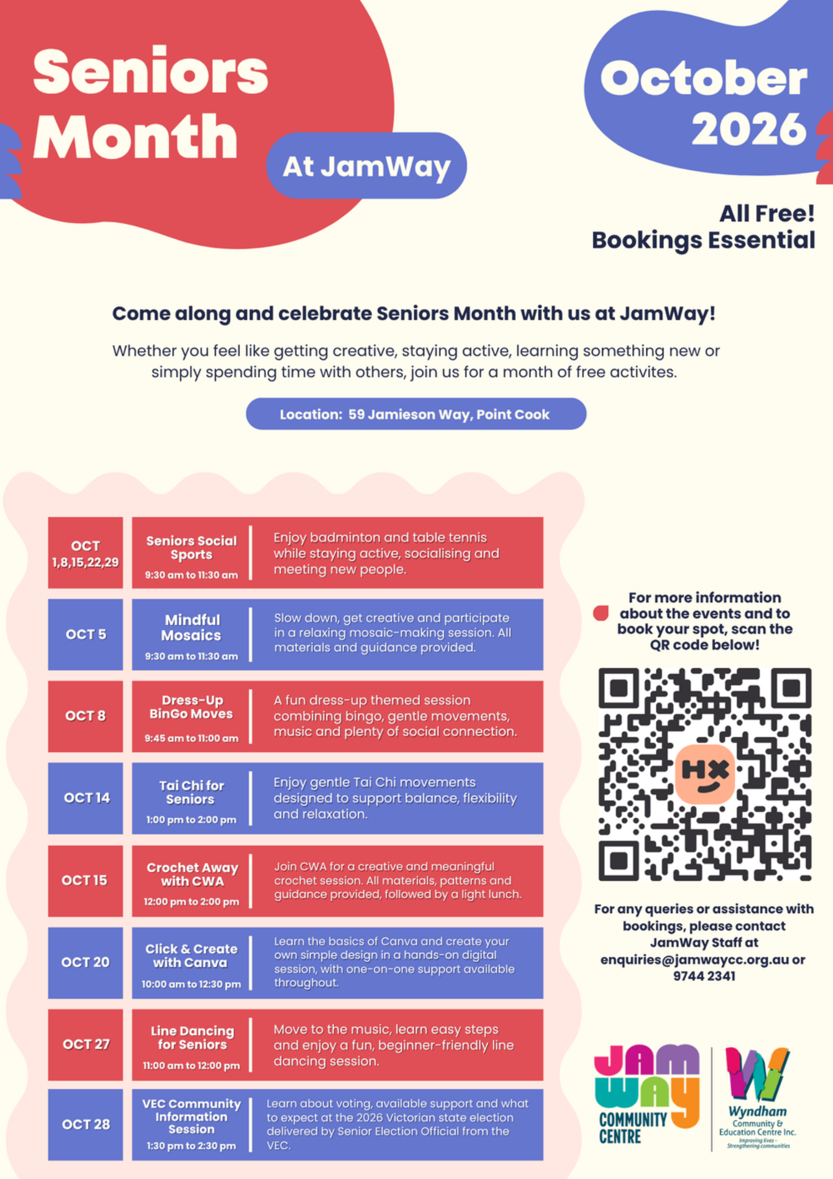
Early years Programs & Activities
Adventure Seekers Art Club | FEES APPLY NEW!  Adventure Seekers Art Club is a community for children who love to explore, experiment, get messy, make things and discover where their ideas might lead. Art Club is built around the belief that children are naturally creative, capable and curious. | Thursdays  9:30am – 10:30am | adventureseekersplaygroup@gmail.com  Instagram: @adventureseekers_
JamWay Community Playgroup | FREE NEW!  A community-led playgroup for children aged 0–5 and their parents/carers, with fun play-based activities and opportunities to connect with local families. A friendly, inclusive space shaped by families’ ideas, interests and voices. Enrolments essential. | Tuesdays  9:30am – 11:30am | JamWay Community Centre:  9744 2341  enquiries@jamwaycc.org.au
Fam Jam at JamWay | FREE NEW!  Join in for a fun, family focused dance and movement session that encourages coordination, motor skill development, and rhythm.  $10 each session, per family (cash only), inclusive of shared fruit platter. Facilitated by Coastal Steps Dance Studio. Bookings are essential to ensure safe room capacity. | Monthly on 2nd Tuesdays  Starting 14 July  9:45am - 10:45am | JamWay Community Centre:  03 9744 2341  enquiries@jamwaycc.org.au
Little Rhythm Co. | FEES APPLY  Little Rhythm Co was created with two core values at its heart: flexibility for families and music with purpose. At Little Rhythm Co you can attend weekly or book as you please, without the stress. Free trial class available. Ages 8 months – 4 years. | Wednesdays & Saturdays  Between 8:30am - 11:30am | Paige  hello@littlerhythmco.com.au

Education & Training Kids & Adults
Adult Migrant English Program (AMEP) | FEES APPLY  AMEP is funded by the Australian Government Department of Home Affairs and provides English language tuition to eligible migrants and humanitarian entrants. Participating in the AMEP gives you the English you need to settle, get a job, study, help your children settle and participate more in day-to-day life in Australia. Eligibility conditions apply. | Mondays  9:00am - 3:30pm  Fridays  9:00am - 3:30pm | Wyndham Community and Education Centre:  03 9742 4013
Click & Create with Canva – for Seniors | FREE  Learn the basics of Canva and create your own simple design in a hands-on digital session, with one-on-one support available throughout. Bring your own devices. Registrations essential. | Tuesday, 20th October  10:00am – 12:30pm | JamWay Community Centre:  9744 2341  enquiries@jamwaycc.org.au
French Class - all welcome I FREE  Bonjour! Make new friends while you discover and learn the French language. Intermediate level. | Tuesdays  1:00pm - 3:00pm | Brian: 0412 564 030
Hedaia Arabic School | FEES APPLY  Hedaia is a youth-focused not-for-profit initiative nurturing Qur’an, confidence, character and leadership in children.It's Arabic & Qur’an School provides a supportive environment where children can learn, grow and build a strong foundation for life. | Tuesdays and Fridays  4:30pm – 5:30pm | www.hedaia.org
Russian Language Classes | FEES APPLY  Operated by the Russian Ethnic Representative Council, offering language classes for children. | Tuesdays  5:30pm - 7:30pm  Saturdays  10:00am - 12:30pm | Katerina.rzh@gmail.com
Schoolola Tutoring | FEES APPLY  Schoolola Tutoring provides academic support programs for students from Prep to Grade 8. Programs include English and Maths tutoring, Selective School preparation, Scholarship exam preparation, and NAPLAN (Grade 3 & Grade 5). LEGO Robotics sessions are also offered to encourage STEM learning and creativity in a fun and engaging environment. | Monday -Friday  4:30pm - 7:30pm | Dinesh Kammi  03 7047 7576  pc@schoololatutoring.com.au  https://schoolola.com.au/
Super Speak | FEES APPLY  Super Speak offers public speaking, presentation skills and drama programs for children aged 6–14, helping young people build confidence, clarity and communication skills in a supportive environment. | Wednesdays  4:15pm - 8:15pm | info@superspeak.com.au
VEC Community Information Session | FREE  An interactive community information session delivered by a Senior Election Official from the Victorian Electoral Commission. Learn why voting matters, what support is available, how to participate in the 2026 state election, and what’s new this election. Registrations essential. | Wednesday, 28th October  1:30pm – 2:30pm | JamWay Community Centre  9744 2341  enquiries@jamwaycc.org.au

Recreation & Wellbeing Kids & Adults
Alankar Music | FEES APPLY  Alankar Music offers Indian classical vocal lessons to kids and adults. These sessions focus on vocal development, rhythmic knowledge and learning traditional compositions with the use of instruments like Tabla and Tanpura. | Saturdays  10:00am - 12:30pm | 1alankarmusic@gmail.com
Aussie Hoops | FEES APPLY  Aussie Hoops is Basketball Australia’s beginner program, designed to help kids aged 5-10 years build skills, confidence, and teamwork through organised sport in a safe and welcoming setting. | Wednesdays & Fridays  4:15pm - 5:00pm | Wyndham Basketball  (03) 9742 5440  info@wyndhambasketball.com
Beat Freakz Fitness – Workout in the dark | FEES APPLY  Beat Freaks Fit is a high energy workout in the dark with disco lights and music. Combining dance, cardio and strength for a fun, empowering fitness experience. | Wednesdays  6:00pm - 7:00pm | Jenna: 0424 124 661  beatfreakzfitness@yahoo.com  beatfreakzfit.com.au
Bingo Moves | FREE  An active and social twist on traditional Bingo, where each number drawn prompts simple movements to music. Designed to be safe, fun, and inclusive, it encourages gentle activity while supporting social connection and overall wellbeing of older adults. | Tuesdays  9:45am arrival for 10am start - 11am | JamWay Community Centre  03 9744 2341  enquiries@jamwaycc.org.au
Coastal Steps Dance Studio I FEES APPLY  A fun community, family friendly dance school for all ages and abilities. Offering Pre-school classes, Ballet, Contemporary. | Mondays  4:00pm - 9:00pm Thursdays  4:15pm - 7:15pm | Jasmine: 0434 111 060  jasmine@coastalsteps.com
Community Bookshelf | FREE  Drop in to take a book, give a book and find a comfy spot to have a read. | Monday to Friday  8:30am - 4:30pm | JamWay Community Centre:  9744 2341  enquiries@jamwaycc.org.au
Courtside | FREE  Courtside is a drop in free, weekly basketball and social program for young people aged 12–25 years. Come shoot hoops, hang out with friends, enjoy snacks and music, or join in friendly 3v3 games. | Thursdays  4:00pm - 5:00pm | Youth Services: 03 8734 1355  YouthInWyndham@wyndham.vic.gov.au
Crochet Away with CWA – Seniors Month | FREE  Join us for a relaxed crochet session with the Country Women’s Association, creating orange flowers for JamWay’s 16 Days of Activism display. All materials provided. Registrations essential. | Thursday, 15th October  12:30pm – 2:00pm | JamWay Community Centre:  9744 2341  enquiries@jamwaycc.org.au
Dress-Up BinGo Moves – Seniors Month | FREE  This Seniors Month, come along for a fun session of Bingo Moves with a dress-up twist! Think funny hats, colourful glasses, feather boas, scarves, bright shirts. Bring your own favourite items or risk the mystery bag at JamWay! Best dressed prizes to be won. Registrations essential. | Thursday, 8th October  9:30am – 11:30am | JamWay Community Centre:  9744 2341  enquiries@jamwaycc.org.au
Fusion Beats by Saishaa | FEES APPLY  A vibrant Bollywood dance experience built on a deep love for movement, expression, and celebrating Indian culture. It’s a fun and welcoming space to connect, build confidence, and enjoy the energy of dance together. | Saturdays  9:00am - 10:00am | Saishaa  saishasethi2603@gmail.com
Glow Haus Pilates Studio | FEES APPLY  Glow from within through strength, balance and grace.  Experience the power of movement in our mat work Pilates class.  No Experience Needed! This welcoming, all levels class, is designed to support you with modifications available for everybody. | Saturdays  8:30am - 9:30am | Nataliedimitriadis0@gmail.com
Half Done and Happening | FREE NEW!  Got a project that’s half done and happening? Join fellow creatives for a relaxed session of making, creating, chatting, and connecting. Just bring your project, your materials, and yourself! | Mondays  Starting 13 July  9:30am - 11:30am | JamWay Community Centre:  03 9744 2341  enquiries@jamwaycc.org.au
Huddle Up Juniors | FREE  Huddle Up! Junior is an afterschool sport program for kids aged 5-12 years which offers young people the opportunity to get involved and get active through social games of multiple sports delivered in a safe and inclusive environment. | Mondays  3:30pm - 4:30pm | The Huddle  Mariam.Taleb@nmfc.com.au
JK Natyalaya Dance | FEES APPLY  JK Natyalaya Dance School running Bollywood style dance classes for kids and adults. | Fridays  6:00pm - 8:00pm | Kanimozhi  kanisuba@gmail.com
Kathak Kendra Nrityashala | FEES APPLY  Join Kathak Kendra’s journey and discover the art of graceful storytelling through rhythm, footwork, and expressions. Classes for all levels. | Tuesdays  6:00pm - 7:00pm | Kathakkendra.nz@gmail.com
Little Kickers | FEES APPLY  Soccer classes for 18month-8 year olds, designed to give children a positive introduction to sport by teaching soccer skills in a friendly, pressure free environment. | Saturdays & Sundays  9:00am - 1:00pm | Varun: 0468 325 265  www.littlekickers.com.au
Line Dancing | FEES APPLY NEW!  Kick up your heels and join us for a beginner line dancing program. Sessions facilitated by Ange from Wyndham Line Dancing. Fun, friendly environment- no experience needed. $5 suggested donation appreciated. | Wednesdays  11am – 12:30pm | JamWay Community Centre:  9744 2341  enquiries@jamwaycc.org.au
Line Dancing for Seniors – Seniors Month | FREE  Kick up your heels and join us for a beginner line dancing session facilitated by Ange from Wyndham Line Dancing. Fun, friendly environment- no experience needed. Registrations essential. | Tuesday, 27th October  11:00am – 12:00pm | JamWay Community Centre:  9744 2341  enquiries@jamwaycc.org.au
Manmohini Indian Dance School | FEES APPLY  Specialising in the art of Kathak dance, which is one of the eight forms of Indian classical dance.  This dance form traces its roots from the tradition of story tellers | Thursdays  7:00pm - 8:00pm | Mohini  mohini@kathakmelbourne.com.au
Mindful Mosaics – Seniors Month | FREE  This Seniors Month, take some time to slow down, get creative and enjoy the relaxing process of mosaic making. This mindful activity is a chance to connect with others while creating your own colourful piece to take home. All materials supplied, no experience needed. Registrations essential. | Monday, 5th October  9:30am – 11:30am | JamWay Community Centre:  9744 2341  enquiries@jamwaycc.org.au
Natya Samarpan Academy | FEES APPLY  A Bharatanatyam School founded by Tanvi Oza - senior disciple of legendary Dr Vasundhara Doraswamy and Smt. Meghala Bhat. Tanvi's focus is on honouring and carrying forward the legacy of the Vasundhara Bani of Bharatanatyam and imparting the purity of Indian classical dance in her students. | Thursdays  7:30pm - 8:30pm | Tanvi Oza  0481 435 964  natyasamarpanacademy@gmail.com
Seniors Board Games I FREE  Friendly social group who enjoys a chat, a cuppa and play board games such as Mahjong and Rummikin. | Mondays  12:30pm - 3:30pm | Maree: 0408 526 897
Seniors Social Sports – Seniors Month | FREE  Join us this Seniors Month for a friendly social sports session where you can play badminton and table tennis, socialise and connect with others. Registrations essential. | Every Thursday in October  9:30am – 11:30am | JamWay Community Centre:  9744 2341  enquiries@jamwaycc.org.au
Shri Nrityam Sadhana | FEES APPLY  Shri Nrityam Sadhana is a structured Bharatanatyam training program guided by Dance Artist & Researcher T Shriraam. Integrating technique, anatomy, psychology and Indic values.  It nurtures dance from foundation to performance. A space for discipline, expression and inner growth – where dance becomes both art and practice. | Mondays  6:00pm - 8:00pm | T. Shiriraam  shrinrityam@gmail.com
Skate Studio | FEES APPLY  The Skate Studio offers fun, inclusive skating classes for all ages and skill levels, from beginners to advanced skaters. Their engaging sessions focus on building confidence, skills, and a love for skating in a supportive environment. | Saturdays  3:00pm - 4:00pm | skate_studio@outlook.com
Sri Lankan Performing Arts | FEES APPLY  Sri Lankan cultural dance group. | Saturdays  12:30pm - 2:00pm | Jin: 0402 513 059  slpafvic@gmail.com
Social Sports at JamWay | FREE NEW!  Join us weekly for a friendly social sports session where you can play badminton and table tennis, socialise and connect with others. Registrations essential. | Starting November 5th  Thursdays  9:30am – 11:30am | JamWay Community Centre:  9744 2341  enquiries@jamwaycc.org.au
Sohum Yoga | FEES APPLY  Yoga - an ancient, holistic practice of experiencing the Self. Come as you are to find harmony between the body, breath and mind and leave feeling strong, flexible and peaceful. | Tuesdays  11:30am -12:30pm  Fridays  8:45am – 9:45am | Radhika  0450 668 237  radhika.gole@gmail.com
Tai Chi for Seniors – Seniors Month | FREE  Enjoy a calming Tai Chi session designed for seniors, facilitated by Wyndham Joyful Home. Take part in gentle movements that support balance, flexibility and relaxation. Registrations essential. | Wednesday, 14th October  1:0pm – 2:00pm | JamWay Community Centre:  9744 2341  enquiries@jamwaycc.org.au
Walking Basketball | FEES APPLY  Whether you are looking to stay active, recover from an injury, or just meet new people, this is for you. Registrations essential -see JamWay staff for assistance with registrations. | Wednesdays  10:00am – 11:00am | www.wyndhambasketball.com
Community Supports & Services
Community Connector | FREE  Wyndham Council has a dedicated team who can help you find and connect with local service options. If you need support, but are unsure of where to start, please reach out. | Mondays  (fortnightly)  8:00am - 5:00pm | 8734 4514  communityconnector@wyndham.vic.gov.au
Narcotics Anonymous | FREE  A self-help group for recovering addicts, who meet regularly for the purpose of recovery from the disease of addiction. Visit their website for more information on different sessions. | Wednesdays  7:30pm - 8:30pm | www.na.org.au
Power Unleashed | FEES APPLY  A hands-on capacity building program for young people living with a disability, focused on real world learning and life skills. | Wednesdays  9:00am - 1:00pm | Graeme@powerunleashed.com.au

Community, Cultural & Faith Groups
Country Women’s Association (CWA Point Cook) | FEES APPLY  CWA supports women across Victoria through friendship, advocacy, and community action. CWA empowers members to make a positive difference locally and globally. | Thursdays  (3rd of the month)  10:30am - 12:30pm | Linda Baker  blee.baker@live.co.uk
CPA Australia – Point Cook Practice | FEES APPLY  Regular meetings featuring expert speakers who explore key topics relevant to today’s professional accountants.  These sessions offer valuable opportunities to exchange ideas, discuss common challenges & expand your local professional network.They also provide the opportunity for local businesses to attend & keep abreast of the changing business environment. | Thursdays  (3rd of the month)  5:30pm - 7:30pm | chris@aletheiawealth.com.au
Encounter Jesus | FREE  Encounter Jesus Ministries Melbourne is a welcoming Christian community, dedicated to life changing encounters with Jesus Christ through worship, discipleship and outreach.  They have a mandate of sustaining the experiential knowledge of God and walking in the fullness of their eternal ordinations. | Sundays  4:00pm - 6:30pm | Azariah: 0418 995 501  ejmiaus@gmail.com
Good Samaritan Ministries | FREE  Church Service | Sundays  2:00pm - 5:00pm | goodsamaritanmy@yahoo.com
Gospel Power Ministries | FREE  Gospel Power Ministries provide various activities including preaching and teaching the gospel of Jesus Christ. A space for people to connect, grow and learn more about life and faith. | Tuesdays, Wednesdays, Fridays, Sundays | Gpmchurch@gmail.com  gospelpowerministrieschurch.org.au
Migrant Resource Centre I FREE  Arts & Craft, gentle exercise, board games & mind games, information sessions for Sri Lankan seniors. | Fridays  10:00am - 3:00pm | Atarjit: 0421 289 140  North West Migrant Resource Centre  Atarjit_b@mrcnorthwest.org.au
Seniors Journey Inc I FEES APPLY  English class and social connections for Mandarin speaking seniors. Participate in activities such as cultural dancing, Taichi, mahjong, cultural discussions. | Mondays  9:00am - 2:00pm | Donghu: 0431 661 107  seniorsjourney@gmail.com
Western Association of Women Seniors Inc. | FEES APPLY  Indian women’s education and welfare, including community health and safety. | Thursdays  (1st & 4th of month)  11:00am - 2:30pm | Chandri Dutta  wawseniors@gmail.com
Wyndham Joyful Home | FEES APPLY  Friendly Chinese social group who participates in English classes, dancing, singing, Taichi. | Tuesdays  9:30am - 1:30pm | Amy: 0477 676 681  Aizhen_g@hotmail.com

